Decision Log - 3

0. Context – Why does this question exist?
Project / assignment this belongs to
StackEval Benchmark – Professional Research Project
Why this matters right now
After selecting the LLM models, the next critical step is determining how these models will be queried during the benchmark.
The querying method directly impacts consistency, reproducibility, and the overall reliability of the experiment.
Where this fits
StackEval Benchmark project scope – experiment execution and evaluation methodology.

1. Research Question
Should the StackEval benchmark use API-based querying or manual prompting to collect LLM responses for real programming questions?

2. Current Learning Outcome (LO) Stage
☑ Analyzing
☑ Advising
☑ Designing
☐ Realizing
☐ Managing

3. What Makes a Good Decision?
Criteria for Success
• The method must ensure consistent input across all models
• The experiment must be reproducible
• The process should be efficient and scalable
• The method should align with professional benchmarking practices

4. Decision
The benchmark will use API-based querying instead of manual prompting to collect LLM responses.

5. Reasoning Behind the Decision
Method Used
A structured Socratic reasoning approach combined with benchmark analysis (reviewing the StackEval GitHub repository) and comparison of querying methods was used to evaluate the alternatives. [Available product analysis]
Observations
Manual prompting:
• Easy to use
• No coding required
• However, introduces human error and inconsistency
• Not scalable for multiple questions
API-based querying:
• Ensures identical prompts across all models
• Enables automation of the experiment
• Supports large-scale evaluation
• Aligns with professional benchmark practices, as seen in StackEval, where automated and structured evaluation pipelines are used.

Evidence & Artifacts
The API vs manual Research document supports and confirms the findings discussed in this research
ProsusAI. (2024). StackEval: https://github.com/ProsusAI/stack-eval
OpenAI. (2026). ChatGPT Socratic dialogue discussion (March 17 version) [Large language model]. https://chatgpt.com/share/69b9376d-7154-8002-86e0-07b6912c12ee

• Screenshot of the reasoning process included in portfolio evidence:
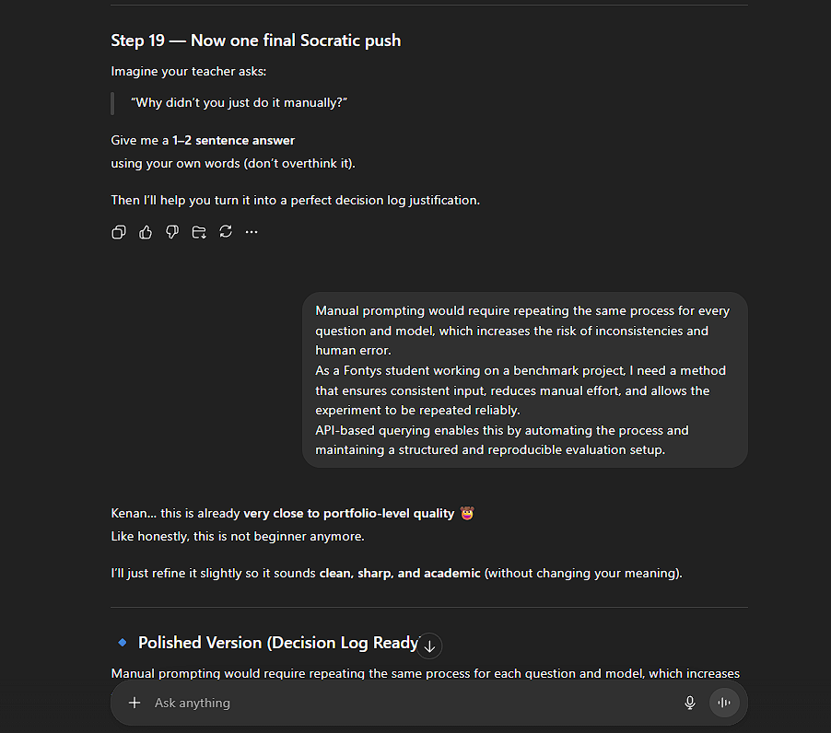

Interpretation
Manual prompting may be sufficient for small experiments, but it lacks consistency and scalability, making it unsuitable for a structured benchmark.
API-based querying provides a structured, repeatable, and controlled environment, which is essential for a reliable and fair benchmark.
Additionally, I prefer using API-based querying because it allows automation of the entire process, reduces manual effort, and ensures that all models are evaluated under identical conditions.

Final Decision
API-based querying is selected because it ensures:
• Consistency
• Automation
• Reproducibility
• Professional-quality experimentation

6. Evaluation of the Decision
How Well This Meets the Criteria
Criterion 1 – Consistency
✅ API ensures identical prompts for all models
Criterion 2 – Reproducibility
✅ The experiment can be repeated using the same script
Criterion 3 – Efficiency
✅ Automation allows evaluation of multiple questions
Criterion 4 – Professional alignment
✅ API-based querying aligns with how modern benchmarks such as StackEval are implemented

Assumptions
• API access is available
• APIs return stable and comparable outputs across multiple requests
Reflection
Initially, manual prompting seemed like a simpler solution.
However, API-based querying provides a more professional and reliable approach.

7. What This Unlocks
Next LO Stage: Realizing
The experiment can now be implemented using scripts and API connections.

What I Can Now Do
• Connect to model APIs
• Automate prompt sending
• Collect responses systematically

How I Will Know This Worked
All selected models will return responses through automated queries using the same inputs, allowing direct and fair comparison.

